**<<TITLE OF THE PROJECT>>**

**In Partial Fulfillment of the Requirements in**

**Integrative Programming and Technologies 1**

**Submitted by:**

**BAJA, ERIN JASMINE C.**

**BUTALID, RYAN C.**

**ESTRADA, CATHERINE D.**

**MANABAT, CATHYRINE JOYCE ANN M.**

**RARUGAL, MA. CHRISTINE ASUNCION B.**

**Submitted to:**

**Associate Professor Geecee Maybelline A. Manabat**

**2nd Semester, School Year 2024-2025**

**TABLE OF CONTENTS**

**INTRODUCTION**

Project Overview

Problem Definition

Project Objectives

Project Scope and Limitation

**FEASIBILITY STUDY**

Overview of the Existing Website

User Overview

**RECOMMENDED SOLUTION**

Design

Content Structure

Interface Design

Overview of the Recommended Website

**DISCUSSION OF THE DOCUMENTATION FORMAT**

**INTRODUCTION**

**Project Overview**

You may discuss the following:

History of the Company (optional)

Nature of Business

Products / Services and Clients

Organizational Charts / Divisions and Departments

This section should give a basic overview of the project and the organization behind it. An overview could include:

**About your organization** – A brief company background and history.

**What problem are you trying to solve?** – Why is the project needed?

**High-level project scope –** Is it a redesign of a few pages, a complete website overhaul, or a brand new website?

**Target market –** An overview of who this website is targeted at. This could also be its own section in the document.

**Problem Definition**

Briefly describe the goals of the project. This will give developers an idea of what you are trying to achieve, which will enable them to suggest the most appropriate solutions.

**Project Objectives**

Use “declarative sentences” to state the objectives

**General Objective**

This is the answer to your general statement of the problem. This expresses the main goal of the recommended website.

**Specific Objectives**

These are the answers to your specific statement of the problems. These include specific goals of the system. Each objective should be explained further in subsequent paragraph(s))

**Project Scope and Limitation**

Discuss who the intended users are, the pages to be developed for each user, as well the reports to be generated. Also, identify the processes which will not be included in the recommended website.

**FEASIBILITY STUDY**

**Overview of the Existing Website**

Discuss the capabilities and limitations of the website currently being used by the company.

**User Overview**

Identify all users of the current site and the roles each page in relation to the website.

**RECOMMENDED SOLUTION**

**Design**

The content of this section will depend on whether a design already exists, or whether creating a design is part of the scope of work.

**Design Exists Already**

If design work has already been completed, then it can be referenced here.

There are many ways to provide design assets, for example:

PDFs (annotated if possible)

Invision project links

Flat image files

PSD files

Sketch files

It is important to provide a style guide and/or annotations for information such as:

colors

typography rules

hover states

animations

grid systems

spacing

#### **Responsive designs**

Today’s websites are viewed on a wide range of devices and screen sizes. It is important to consider how your site will look, especially on small screens such as smartphones.

Mobile designs (and possibly tablet sizes) should be provided along with the usual desktop designs.

### **Design as part of the project scope**

If the visual design is part of the project, you will need to give guidance on the constraints and desired stylistic direction.

For example, if your organization has brand guidelines that should be adhered to, they should be included here.

Each designer will have their own process, but it can help to provide:

Brand guidelines – such as colors, fonts, logos, other graphic

Print material – brochures, business cards, etc.

Analysis of competition – what you like and don’t like about their websites

Examples, and reasons for, websites that you like and dislike

**Content Structure**

Content structure, or Information Architecture (IA), is comprised of various parts and will depend on the complexity and size of your website content.

**OR**

**Site Map**

This is usually provided as a diagram which shows the ‘tree’ type, hierarchical structure of the website pages. It can also include which ‘page template’ (see below) to use for each page and content type.

Credits to https://webstyleguide.com Image link: https://webstyleguide.com/wsg3/1-process/2-development-team.html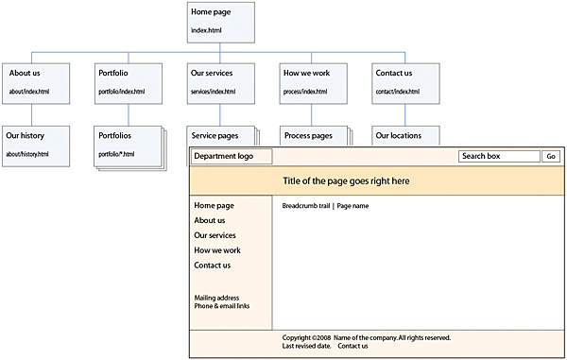

**Interface Design**

Develop the complete screen shots / interface of all the pages of the website for all of its users. 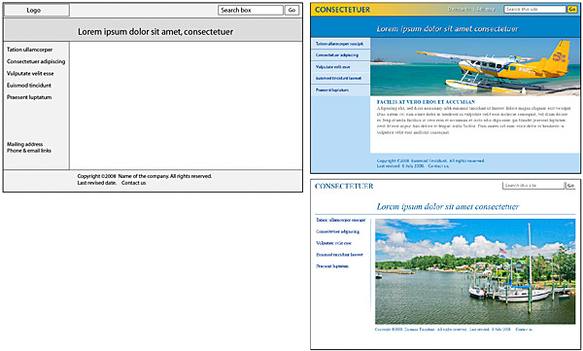

Credits to https://webstyleguide.com Image link: https://webstyleguide.com/wsg3/1-process/2-development-team.html

**Overview of the Recommended Website**

Discuss the capabilities and limitations of the recommended website.

Functionality is how your site actually works. This could be anything about specific parts of the website that need additional explanation.

For example, if you have a signup page, what fields are required? What happens to an entry on a contact form?

Many sites require integrations with third-party APIs. If this is the case, then these integrations should be outlined here in terms of how they will work and any additional information that is needed. A good example of an integration is showing a feed of latest Tweets on your site.

Here are some examples of functionality you may want to mention, depending on your project.

e-Commerce functionality such as payment gateways

SSL (Secure Socket Layer) – is this required and how it should be implemented

Multi-lingual capabilities

User roles and capabilities – more than 1 type of user role where users can have different permission etc.

Analytics and tracking

Specific functionality around search

Performance requirements

**APPENDICES**

**PROJECT TEAM**

A list of the decision makers involved in the project. It is useful to include job titles or project roles.

The project lead should both be highlighted here.

For example:

Albus Dumbledore – **Project Manager** – responsible for overall development and implementation of a project as well as for day-to-day operations

Severus Snape – Requirement Analyst / Graphic Designer – The **Requirement Analyst** is responsible for analyzing the requirements for the project and translate it into specifications that can be used by the Project Manager in setting time frames. The **Graphic Designer** is responsible for the look and feel of the project: pleasing, aesthetic, inviting, and engaging.

Hermione Granger – UI/UX Designer / Web Content Manager – The **UI/UX Designer** is responsible for creating a wireframe, which is a schematic placement of elements on the website to effectively solve the difficulty/ies that the user might face. The **Web Content Manager** is responsible in organizing and categorizing web site structure and content.

Harry Potter – **Web Developer (Front-end Developer) / Web Technology Lead** - responsible for converting initial web site page mockups, designs, and wireframes into html pages. Once the site has been planned and the design and information architecture plans have been completed, the site production lead manages the work of building the site’s pages, either directly in “plain” html or within a web content management system (cms) or using web site production software

Ronald Weasley – Web Quality Assurance Specialist (QA) – The **Web Quality Assurance Specialist** is responsible for testing the versions of the product. The test processes may start at the beginning of the project after the first version is available.



**PICTURES AT WORK**

**NOTE: 3-5 pictures**

**PROJECT FOR CIP1101**

**Project Groupings:**

Maximum of 6 members in a group. Minimum of 2 members in a group.

**Project Description:**

Create a collaboratively designed web site that addresses the significance of simplicity, usability, navigation and aesthetics.

**Project Guidelines:**

The website must have these main pages of a website.

Home Page /Main Page

About Page

Product Page

FAQ Page

Testimonials / Review Page

Contact Page

The project will be presented to a group of panelist, where the significance of each pages will be discussed.

**General Guidelines for the Documentation:**

Use the following:

Short bond paper

Font – Arial 11

Line spacing – 1.5

Alignment – Justify

Page Margin - Left – 1.5”; Top, Right, Bottom – 1”

Page number – placed at the upper-right corner (Arial 9)

References:

CCSS BSIT Thesis Documentation

Guide: Writing effective website specification documents by Mark Wilkinson (Feb 6, 2018)